TOPIC 1: USE AND MANAGEMENT OF WATER RESOURCES
Water is the livelihood of the biosphere. It connects us to one another, to other form of life, and to the entire planet. Despite the importance, water is one of our most poorly managed resources. We waste it and pollute it. We also charge it too little for making it available. This encourages still greater waste and pollution of this resources, for which we have no substitute.
How much Fresh water is available?
Only a tiny fraction of the planet’s abundant water is available to us as fresh water.
- 97% of water on earth is salty
- 3% of water on earth is fresh water
Note that 3% of freshwater is divided among surface water (rivers, swamps, lakes) Ground water and glaciers.
While water is abundant sufficient water is scarce, unevenly distributed and easily misused. Approximately in 2025, I in every 3 people will be living in countries with inadequate fewer water supplies.
As the world’s population grows, and with increasing urbanization, more and more pressure is being exerted (used) on natural resources particularly water. This is particularly true in the Pacific islands, with the small land area and fragile resource base. Students need to be aware of the uneven distribution of water resources around the world, and ways in which water is being used and misused. They should be aware of different strategies for managing water resources and be able to evaluate their efficiency and usefulness.
Note that water is an infinitely renewable resources.
Key Terms
- Resources: anything that can be used to satisfy human needs and wants.
- Natural resources – natural things that are used to satisfy needs and wants of people.
Eg. Plant, vegetation, water, sunlight, marine, etc…
- Cultural resources – man made things that are used to satisfy people’s everyday needs and wants.
Eg. Buildings, prehistoric sites, object or collection, food, vehicles, boats, airplanes, etc...
- Renewable resources – things that can be used repeatedly or from new/other things or used for other purposes.
Eg. Wind energy, hydropower, solar energy, biomass energy (refers to organic material from plant and animals such as woods, etc...)
- Non-renewable resource – natural substance/ energy come from sources that will run out or will not replenish in our lifetimes or even in many lifetimes. It is a finite (limited in size) resource.
Eg. Fossil fuel such as gas, coal, petroleum, phosphate, etc…
- Hydrological cycle – it is a cycle where water circulate in different forms, within the earth, above the earth and on earth.
- Resource management – ways of managing the use of resources
- Infiltration – is the movement of water into ground from the surface.
- Run-off – water flowing down on the surface of the land, slopes, down into the surface of water bodies such as ocean, river, lake, etc…
- Evaporation – the change from water to gas
- This happens when the sun heats water from oceans, lakes and other water sources is transformed into water vapour.
- Precipitation – different form of other substances from the atmosphere to the land
Eg. Rain, snow, sleet, etc…
- Ground water – water source supplied by water table underground
- Condensation – change of water from gas (vapour) to liquid
- Warm rising air cooled and water vapour is transformed into water droplets which form clouds. The droplets increase in size until they fall as precipitation.
- Transpiration – loss of water from plants through leaves into the atmosphere.
- Water table – an area between the parent material and where water material is stored/ receive large amount of water.
- Wetland – area that consistently experience rain.
- Perception – ability to make own opinion
- Water surplus – access to more than enough water
- Water scarcity – access to less than enough water/ is the lack of sufficient available water resources to meet the demands of water usage within a region.
- Well – underground storage that can be used to access to water.
- Irrigation – transfer water from where is abundant, to areas of less water or none at all or areas that does not receive water.
- Hydropower – using of water to generates electricity
- River discharge – flow of river to other water bodies. E.g. streams
- Drought – long period of no rain
- Reservoir – use to store water for period of use in future needs

(Note that these terms will be your spellings. You need to study it in order for you to have a quick learning throughout this unit)

Learning Outcome 1: Nature and global distribution of water resources
Key ideas:
- key terms (define and give examples)
- Global patterns of fresh water distribution
- (identify and locate areas of water surplus and areas of water scarcity)
- diagram showing features of the hydrological cycle 9how water moves through this cycle and the distribution of water resources within this cycle)
In the Global pattern, the distribution of water is unevenly distributed. At the simplest level, the world is divided into TWO major areas, area of water surplus and area of water deficit.

Factors about water
- abundant water in some areas
- not all sources of water are useable for all purposes
- unevenly distributed
- easily misused
- “renewable” resource
Approximately
- 97% of water earth is salty
- 3% of water on earth is fresh water
Note that 3% of freshwater is divided among surface water (rivers, swamps, lakes) Ground water and glaciers.

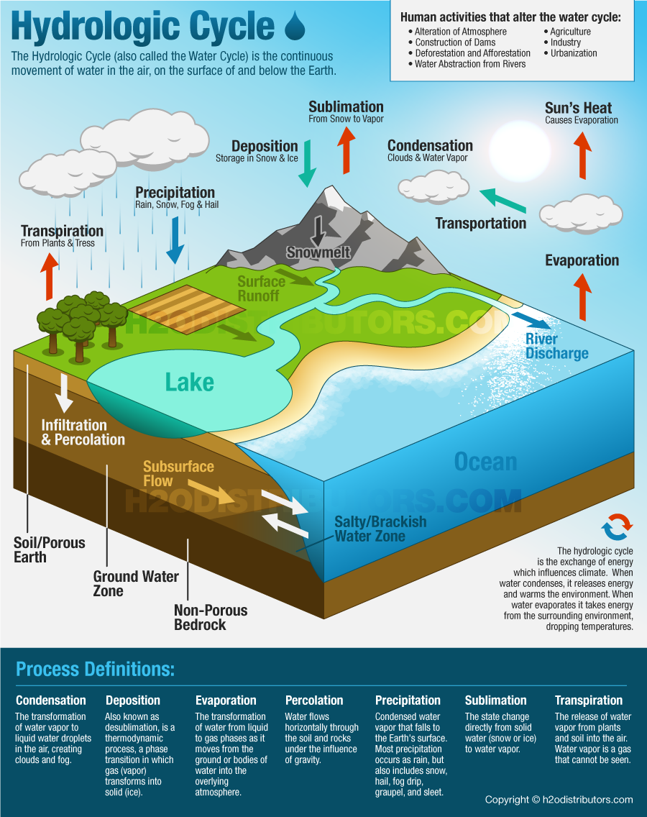
HYDROLOGICAL WATER CYCLE

Infiltration

Evaporation – the transformation of water from liquid to gas phases as it moves from the ground or bodies of water into the overlying atmosphere.
Condensation – the transformation of water vapour to liquid water droplets in the air, creating clouds and fog.
Precipitation – Condensed water vapour that falls to the Earth’s surface. Most precipitation occurs as rain, but also includes snow, hail, fog drip, and sleet.
Transpiration – the release of water vapour from plants and soil into the air. Water vapour is a gas that cannot be seen.
Infiltration – is the movement of water into the ground from the surface.
Surface Runoff – water flowing down on the surface of the land, slopes, down into the surface of water bodies such as ocean, river, lake, etc…
Activity
- Describe the distribution of water resources within this cycle.
________________________________________________________________________________________________________________________________________________________________________________________________________________________________________________________________________________________________________________
- Describe the processes in the hydrological cycle; evaporation
________________________________________________________________________________________________________________________________________________________
- Describe the processes in the hydrological cycle; runoff
________________________________________________________________________________________________________________________________________________________
- Describe the processes in the hydrological cycle; condensation
________________________________________________________________________________________________________________________________________________________
- Describe the processes in the hydrological cycle; transpiration
________________________________________________________________________________________________________________________________________________________
- Describe the processes in the hydrological cycle; precipitation
________________________________________________________________________________________________________________________________________________________

Learning Outcome 2: Factors and processes that affect the global distribution of water resources.
Key Ideas:
- Natural factors causing some part of the world to have surplus of fresh water, while others have a scarcity.
The natural factors below explain why some parts of the world have a surplus of fresh water, while others have scarcity of water.
*water surplus – occurs when there is excessive precipitation
*water scarcity – occurs when there is insufficient precipitation
- Location (latitude)
A. Generally saying, regions of water abundance is very closely associated with the regions of tropical rainforest which generally lie within 10N and S of the equator.
The principal regions are:
- Lowland of the Amazon (South America)
- Islands of Indonesia, Sri Lanka, Philippines and Malay Peninsula of S.E Asia
- Congo basin of Central Africa and parts of W. Africa
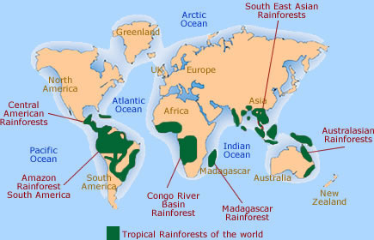

Characteristics of Water Surplus
- Generally; Evaporation < Precipitation = water surplus
- Area of low pressure
High temperature high evapotranspiration
High humidity high rainfall which results in luxurious forest

B. Hot Desert locations
On the contrary, regions of inadequate and insufficient water supply (water deficiency) are closely associated with the desert regions. These regions are generally located along or near the tropics.
The principal regions are;
- Sahara and the Arabian deserts
- Atacama and Patagonian deserts
- Central Australia
- Gobi desert (Central Asia)
- Thar desert (India)
- Colorado and California desert (N. America)
HOT DESERT REGIONS
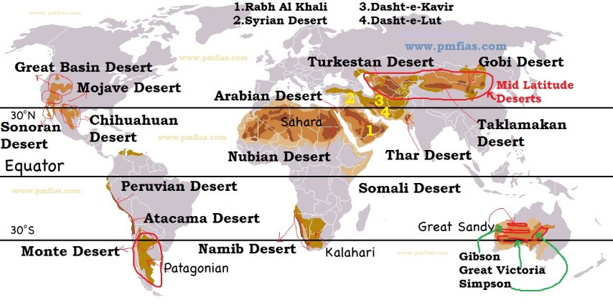

Characteristics of Water Scarcity
- Generally Evaporation > Precipitation = water scarcity
(Evaporation exceeds precipitation)

Deserts are grouped as:
- Sun-tropical e.g. Sahara
- Coastal e.g. Atacama and Colorado
- Inland e.g. Australian desert

- Currents (cold currents)
The occurrence of most coastal deserts are due to the cold currents that flow off-coast eg.
- Atacama
- Colorado
- Kalahari
- W. Australia

Cold Currents

E.g. Peruvian/Humboldt
- California current
- W. Australian current
The cold current allows very little moist in the air therefore, no change of any cloud formation and rain takes place.

- Relief / Rain shadow Effect
E.g. Central Australian Desert
All moisture carried by the SE trade (prevailing winds) is lost on the eastern coast with the eastern highlands as the barriers. The descending air is dry and cool, creating very little amount of rain to be received inland.

- Seasonal Rain and Drought.
Mainly caused by the shift of the ITCZ North and South of the equator. The pressure belts and the prevailing winds move with the shifts causing the seasonal climate
E.g. SW. Australia
Winter-rainy influences of the westerlies

*Solstice time in N. Hemisphere – high temperature, high evapotranspiration high rainfall.
*Solstice time in S. hemisphere – high rainfall while some northern regions receive very little rain.

Distribution of Water
- 97% - stored in the world ocean
- 3% - land (soil)

2.5% 0.62% 0.03%
- Ice sheets - ground water - 0.0001% streams and channels
- Glaciers - 0.0001% atmosphere
- 0.0005% soil water
- 0.0001% fresh water and lakes
- 0.008% saline lakes and inland sea

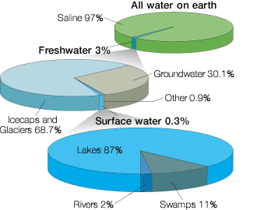

The world’s uneven water supply
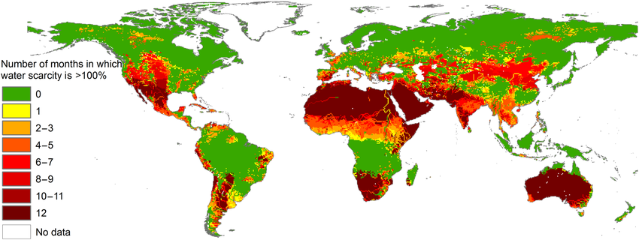

- In developing countries, drinking water is often drawn from the same source as that where bathing and laundering is done and where human waste is deposited thus leading to the creation of water-based diseases 80% of diseases in developing countries).

The problems associated with water supply;
- Insufficient and unreliable rainfall one third (1/3) of the land is too dry for agriculture many other areas are suffering from either;
- a seasonal drought or
- variation in the amount of rainfall from year to year
Some developing countries seem to have the least reliable and suitable water supply e.g. Sahel countries (Sahara desert)
People have to walk several kilometres to get water (very tiring time consuming and usually it’s women’s work)
- In some developed nations where water is abundant; it is not always suitable and safe for consumption and domestic work. E.g. Northern Hemisphere – most have sufficient and safe piped water supply. Southern Hemisphere – only 2 out of every 5 people have access to safe water. Rural areas are at less likely to have clean water and sanitation compared to urban areas.
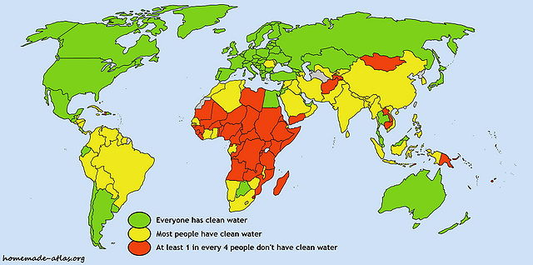
Clean water and adequate sanitation

Activity
- Identify continents which usually have sufficient water
________________________________________________________________________________________________________________________________________________
- Identify continents which always deficient and little access to safe water?
________________________________________________________________________________________________________________________________________________

- Use the map below to name the desert regions numbered below.
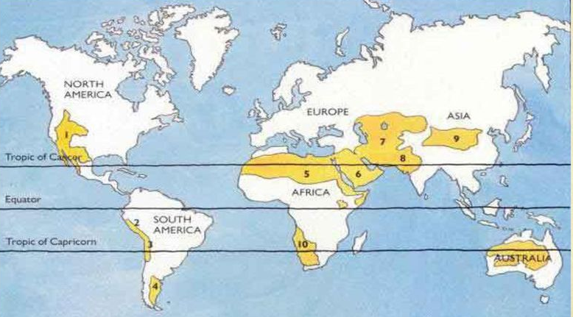
- _________________________ 6. __________________________
- _________________________ 7. __________________________
- _________________________ 8. __________________________
- _________________________ 9. __________________________
- _________________________ 10. __________________________

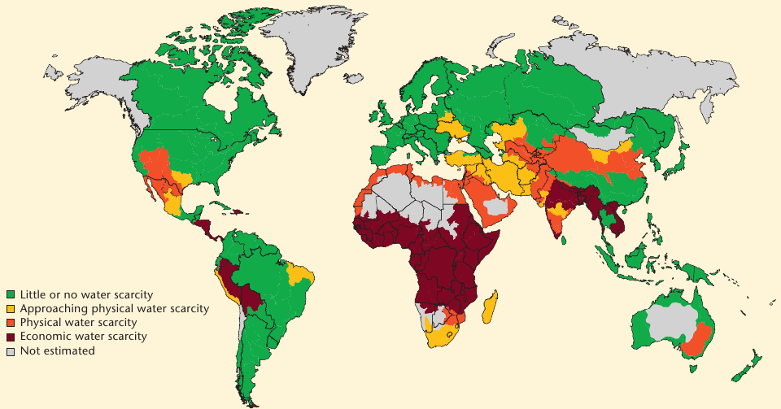
- Use the map below to name three areas /countries with;

- sufficient water supply
_________________________________
_________________________________
_________________________________

- insufficient water supply
_________________________________
_________________________________
_________________________________

Learning Outcome 3: Water use and Effects of Water utilization on people and their environment
Key Ideas:
- People’s perception of water as a resource varies from place to place, culture to culture and time to time
- With the aid of case studies, how water can be used for a variety of purposes – agriculture, domestic and municipal uses (cooking, drinking, washing, sanitation), manufacturing industry, power suppliers, recreation, transportation.
- Positive and negative effects of water use and examples
People’s perception of water as a resource varies from place to place, culture to culture and time to time.
For example;
- Nauru – water is a precious resource that has to be imported from overseas while people living in villages in the wet zone of Viti Levu take water for granted and do not worry about leaking taps.
- In developed countries – USA – people think nothing of using vast quantities of water for washing cars, irrigating lawns, and automatic dish-washing machines etc. while in less developed countries such a Nigeria, people walk many kilometres every day in order to collect just one bucket of water.
Uses of water
- To sustain reasonable quality of life, it requires about 8Liters of water per person every day.
- Average consumption range from:-
- 5.4 litres/day (Madagascar)
- 500 litres/day (USA)
This reflects the fact that there is unequal access to water.
Three Major Uses of Water
- Irrigation
- 73% accounts for irrigation as it vital for agriculture
- Keeps the supply of food going as it increases agricultural produce from crops to livestock
- Without water, crops and animals will die
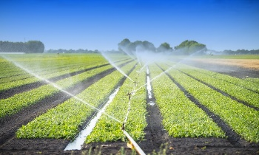
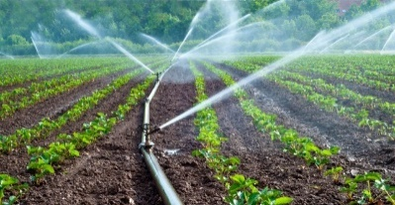
- 12% of the world’s cultivated land is irrigated more than once a year contributing to 20% of the global harvest.

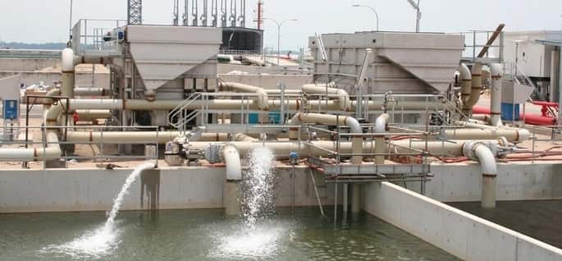
- Industrial Use
- 22% account for industrial uses
- Without cheap supply of water, industries would grind to a halt. Water is used as a coolant, solvent and dilution, cleaning and washing.
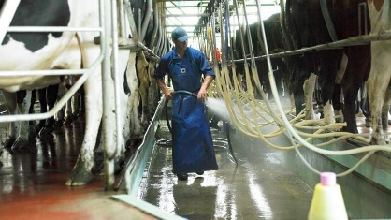
- Continuous supply of products, services and employment which satisfies human needs and wants depend entirely on water.
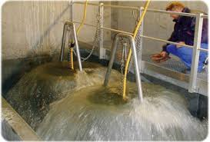
- Tourism as an industry – water plays a very important role in recreational activities e.g. swimming, surfing, sailing, yachting etc.
- Trading of bulky goods using cargo ships
- Fishing and fish farms

- Domestic Use
- Domestic uses include washing, cooking, drinking and sanitation
- Water consumption reflects not only how much water is available per head but also how difficult it is to fetch or how expensive it is to buy.
- Countries with piped water supply consume much water than people in the developing countries where 2km walk is not unusual
- 1 cubic meter of poor quality in third world countries-$20
- 1 cubic meter of high quality water in the rich countries-$10
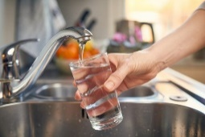
An urban third world household with one running tap may use 40% more than its rural equivalent.
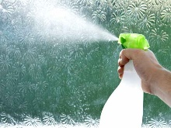
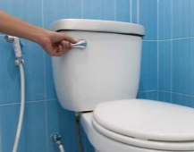
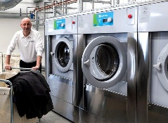

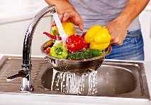


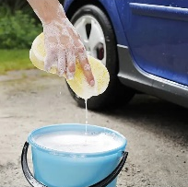
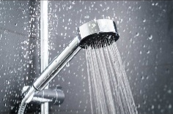
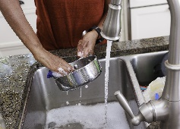

Effects of Water Utilization on People and the Environment.
- Our lifestyles depend on the availability of fresh water. If our taps were running dry, our household routines would collapse and our health will be in dire straits. The entire fabric of our society could begin to unravel. We may take fresh water for granted in short, but we will face great danger in the future.
- Economic Effects
- Improved agricultural productivity through the use of irrigation
- Continuous functioning of industries in producing goods needed by human
- The development of new technological ideas and technologies, bring the one distant world into a smaller and local basis
Recreational Activities
- Tourism is a fast growing industry especially in the developing nations without any economical resources and minerals.
- Trading, cargo ships, trading and transporting bulk of huge amounts of goods.

Aquaculture
- Farming fish and marine lives is another fast growing industry and is earning high income.
- HEP (Hydro Electric power) is much cheaper than using diesel to produce electricity-which very economical and successful.

- Environmental Effects
*Water pollution
- Untreated wastes, drained into the water, polluting and killing the living organisms there.
- Contaminating of water supply creates diseases
- Same source of water for washing, cooking, waste disposal, consumption and bathing etc. create water borne diseases. E.g. Typhoid, malaria etc.
*Beautify the environment
- keep grass green
- keep flowers, gardening blooming

*Salinisation
- High temperature capillary action (upward movement of water)
Water evaporated and leaves a thick layer of salt on the surface. E.g. Atacama Desert.

Dam Building
- Irrigation cannels and channels provide breeding ground for insects, causing of diseases such as malaria, typhoid etc.
- Increase water seepage and evaporation
- Loss of cultivated lands as it will be underwater

- Social Effects
- Building of dams mean the resettlement of population upstream as water rises
- Provision of water supply improve people’s: Wealth and general cleanliness (better sanitation)
- Socialization in water supply, e.g. yachting, swimming, fishing, surfing etc.
- Source of food for fish and other marine lives
- Source of money and provides employment and improve the standard of living

- Political Effects
- Conflicts over countries over building of dams, especially 2 or 3 regions sharing the same water
- Illegal connection of piped water, after official disconnection (excess bills)
- Government takes over the plan and management of water supply
- Health department has to approve the quality of water distribution

Activity
- Describe ways in which people use water
_________________________________________________________________________________________________________________________________________________________________________________________________________________________________
- Explain negative effects of using water on the environment
____________________________________________________________________________________________________________________________________________________________________________________________________________________________________________________________________________________________________________
- Discuss positive effects of water resources for local people.
_______________________________________________________________________________________________________________________________________________________________________________________________________________________________________________________________________________________________________________________________________________________________________________________
- Discuss with examples people’s perception of water.
_______________________________________________________________________________________________________________________________________________________________________________________________________________________________________________________________________________________________________________________________________________________________________________________

